Ex.No:- 3

Date:-28/04/2023

**DML Commands – INSERT, SELECT, UPDATE, DELETE**

**Aim:**

To perform Data Manipulation Language (DML) Commands such as INSERT, SELECT, UPDATE, DELETE in the table.

**Description:**

**INSERT**:

Populate all the five tables with your own data.

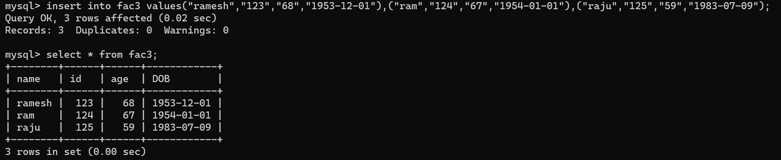

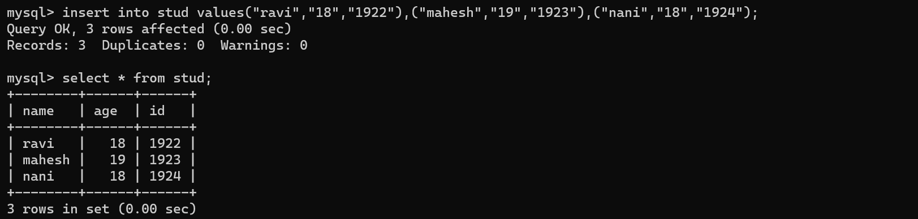

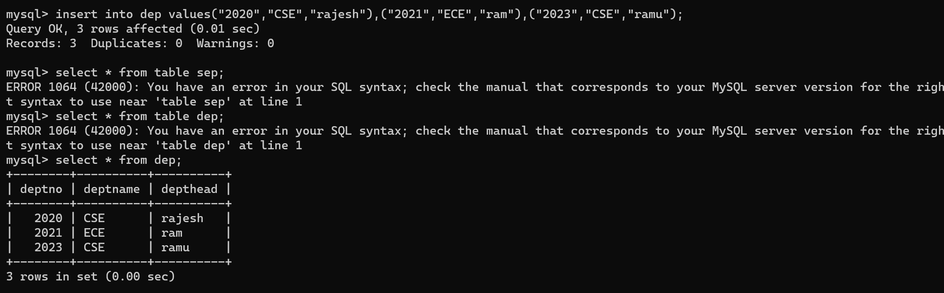

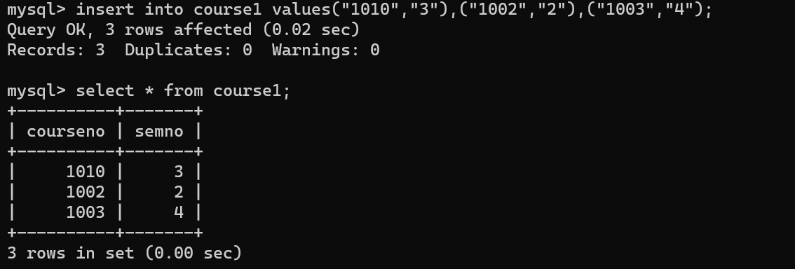

**UPDATE**

Update the value of student name whose register number is ‘191711342’

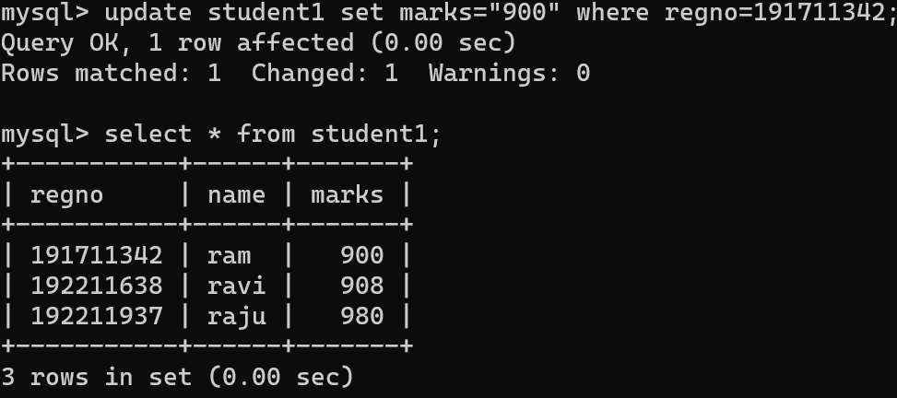

**DELETE:**

Delete the record in the table FACULTY, who resigned her job.

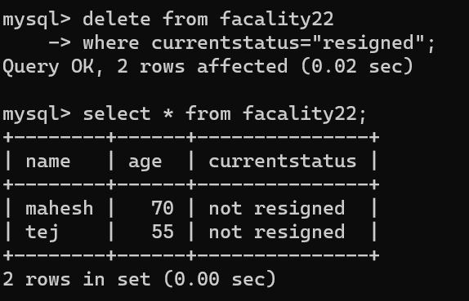

**MODIFY: -**

Modify the date of birth for the faculty whose name is 'RAM' with a value ‘1983-05-01’.

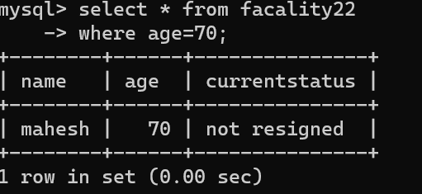

**REMOVE**

Remove all faculty who are having over 65 years

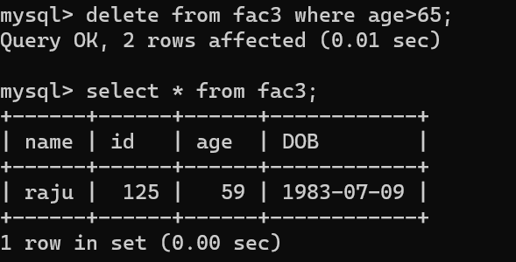

**View all the records from the five tables.**

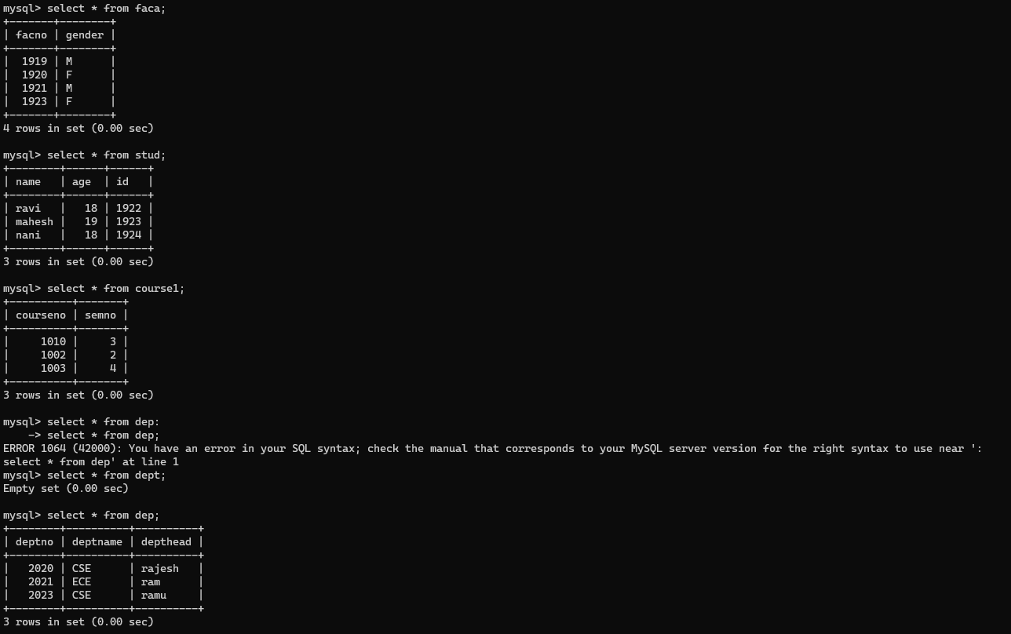

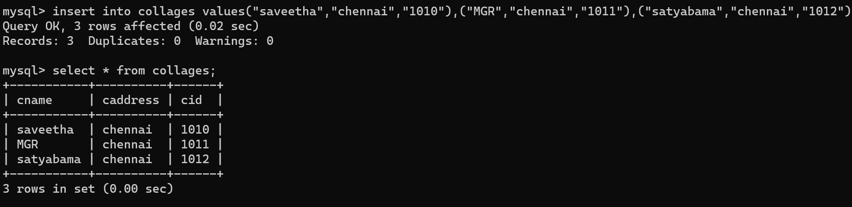

**RESULT**:

Data Manipulation Language (DML) Commands such as INSERT, SELECT, UPDATE, DELETE are performed in the five tables.